e- Commerce plan VO-Cars

1 Introduction

1.2 Introducing the business

Actually, VO-Cars is located in Torhout but with the web shop , we want to make it more convenient for our clients to buy nearly new and new car parts online. Generally, we’re a B2C company but garage keepers for instance can also buy on our website, which is then an example of B2B. With the web shop, we want to increase the number of clients and create more brand awareness.

2 Situation analysis

2.1 Analysis of the external environment

The external environment analysis includes the opportunities and threats from the SWOT-analysis.
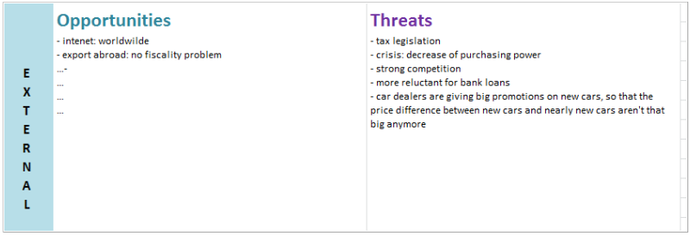
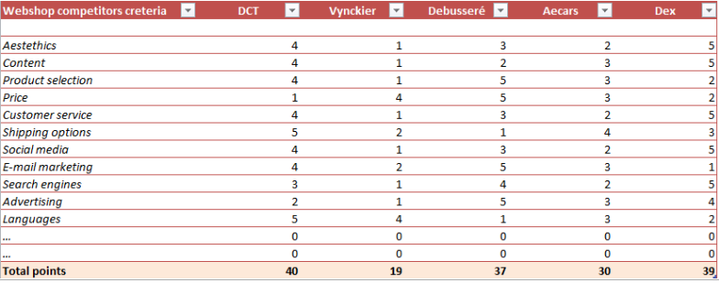

2.2 Analysis of the internal environment
This is often called describing the “As-Is” situation. It's an audit in the company to understand those topics which are relevant for our future e-business solution. The sectors we cover of the audit are:
- Current marketing approach
These days, it’s important for marketers to approach their market via the internet with the use of social media for instance. The internet is becoming more and more popular comparing to traditional media (television, radio, printmedia,…). Nowadays, it’s a trend of consumers to buy online.
- Current internet presence
We have an informational website with our offers, our team,… Furthermore, we also have a Facebook page and a web shop.
- Current resources and skills
We have an ICT professional in our company to manage the website. This takes about 15 % of his time. The other part of the website, namely the web shop, we will outsource because we haven’t the current resources and skills to create it. We also have one person available 20 % of her time for communication management (Facebook, ‘contact’, FAQ). Later, this person also can be responsible for the questions asked via the web shop. Next to this, we also have one person who is responsible for setting and adjusting prices. That same person also creates the product catalogue for the coming web shop. This task takes about 15 % of his time. Like most other companies, they also have persons (all the sellers) who are responsible for customer service and after sales.
- Processes and infrastructure to deliver to the customer
We have one shop, located in Torhout where people directly can buy their products. If they don’t have the time to come to our shop, they can place an order online. If they buy below the 100 euros, the delivery costs are for the customer. If the price is higher than 100 euros, the delivery costs are for the us.
- ICT landscape
First of all, we make use of Enterprise Resource Planning.
Besides that, we make use of CRM to improve and optimize the relationship with our customers.

2.3 SWOT analysis
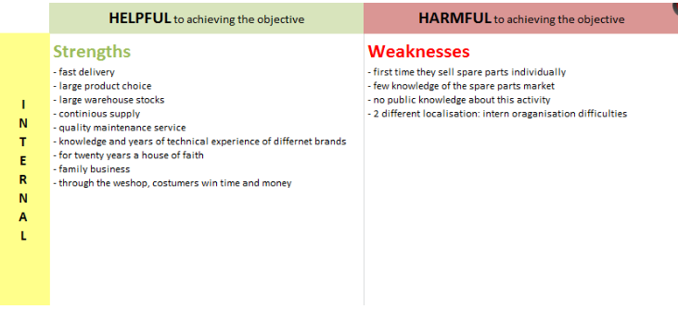
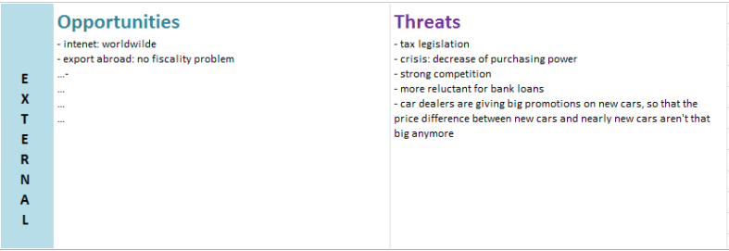

3 Objectives

3.1 Business objectives
VO-cars’ mission is to provide a trading platform where anyone from Belgium can trade a lot of nearly new and new car parts. We want to make it more easy for the customers to buy our products online without having to go to our shop in Torhout. That way, we will continue to increase the number of clients and create brand awareness.

3.2 Detailed objectives

3.2.1 Tangible benefits
Due to our web shop, we will increase sales which will address a geographically more spread customer base (only Belgium!) then what we can cover through our real-life shop in Torhout. We will also put new promotions on our web shop every month. A goal we also want to reach is that every client has a response on his/her question within a day.

3.2.2 Intangible benefits
We would like to increase the online brand awareness with 30 % in the first year and achieve a customer satisfaction of 80 %.

3.3 Critical success factors
First of all, we need to do a lot of advertising in our current shop and via social media so that way, we could increase the online brand awareness. When customers know they can buy our products online and they see we give monthly new promotions, we also reach the goal of ‘customer satisfaction’. As mentioned before, we also have a person who is responsible for communication management, so it shouldn’t be a problem to answer the customer’s question within a day.

4 Strategy and Tactics

4.1 Channel?
Because of the fact that internet is becoming more and more popular nowadays, we stay focused on the online platforms like our social media, our website and of course or web shop. Naturally, we also have our current shop in Torhout to sell and promote our products

4.2 Product?
The products which we offer in our current shop are the same as the ones on our web shop.

4.3 Market?
With our shop in Torhout, we only reach people who lives in Torhout or nearby. Due to our web shop, the whole Belgian population can buy our products.

4.4 Process and Structures?
Some of the processes have to change within the company because of the implementation of the online shop. Especially, when there are incoming orders from people who buy via the web shop, they will have to check whether the products are in stock. So, they have to have a sort of computer program for that. If the goods aren’t in stock, they have to order them to their supplier and else, the demanded products will be delivered to the customer as soon as possible with DHL (most of all within 2 days).

4.5 Price and promotions?
We decided to offer the same price on our web shop as in our current shop. When people buy something on our web shop below the 100 euros, the delivery costs are for them. Else, we will pay the delivery costs. Further, we offer each month also promotions on our web shop.

4.6 Your place in the sales process?
The place of the web shop of VO-cars in the sales process is definitely ‘the seller’. The aim of the company is to promote and sell their products directly to the customers. The products with the prices are mentioned on the web shop and there’s no negotiating about it.

5 Resources and budget

5.1 Project timeline assumption
Services | Start Date | Duration | End Date
Analysis, Design & Implementation | 9/12/2012 | 60 | 7/02/2013
Ongoing Operations | 8/02/2013 | 1086 | 30/01/2016

5.2 Tasks & Resources
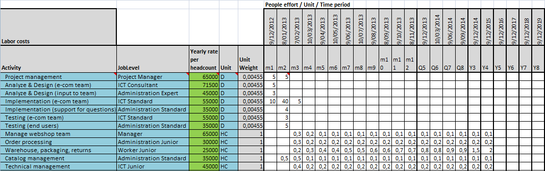

5.3 Headcount evolution to run our project

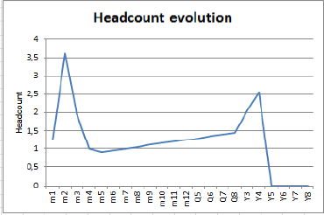

5.4 Non-labor costs

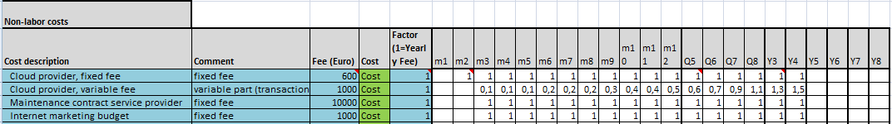

5.5 Total budget

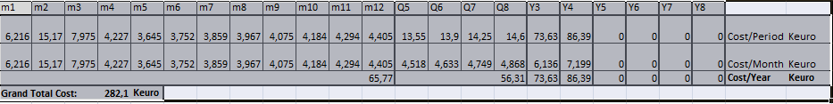

5.6 Month over month budget requirements
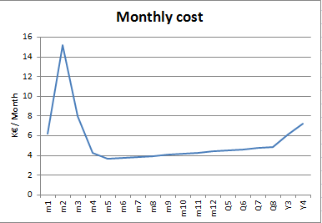

5.7 Conclusion
The costs are the highest in the first 3 months because of the start-up of the web shop. In the beginning, we needed people to build the web shop so it’s normal that the costs are high in the beginning. We have to do a lot of promotion to make our web shop become a success. If we see that sales decline on our web shop, we’ll stop the web shop and thereby, we only will sell in our current shop.

